Outsourcing of Finance-Accounting in View of the Requirements Arising from the Implementation of the Standard Audit File for Tax
Magdalena Chomuszko
(Sage Ltd., Poland)
Abstract: Since 2005, the OECD introduces a truly revolutionary change in the form of tax inspections of taxpayers. This change involves collecting data directly from the tax books and reporting them to the tax authorities in an electronic format, using the files in xml format, which is called Standard Audit File for Tax (SAF-T) and in Poland it is called the Single Control File. This form of settlements with the authorities, forces taxpayers to computerize their businesses, as well as to perform a more careful approach to recording the data. It can be expected that the outsourcing of financial accounting will become more important in the near future, and the demand for such services will grow very high. One should be awared, however, that such a growing demand will imply many challenges for the outsourcing companies. The author has been providing trainings on the Standard Audit File for one year already. During these trainings she observed that taxpayers are not quite aware of all the consequences of the e-checks implementation by the Ministry of Finance. She decided to investigate the level of preparation of accounting offices in order to address the challenges to the new requirements of the tax authorities. The answers to the questionnaire unfortunately confirmed the initial assessment of the situation, that it becomes necessary to take this topic and discussion about the directions being well prepared for the upcoming changes.
Key words: SAF-T; outsourcing; accounting; tax
JEL codes: K
1. Standard Audit File for Tax in Europe
The first document that was prepared by the OECD was entitled “Guidance for the Audit File Tax” and presented in May 2015. It described SAT-T as: “file including reliable accounting data, related to a given period of time, which were exported from the accounting system, which are easy to read due to its standard format and scope.” (Organization for the Economic Co-operation and Development, May 2005). That solution should improve controlling activities and tax audits. It is also expected to help execute tax law in a more efficient way. The elaboration from 2005 described the first version of SAF-T, while in 2010 the next document was prepared where SAF-T 2.00 was presented.
So far, e-controlling based on OCED have been implemented in the following countries: Portugal, Luxemburg, France, Austria, Lithuania, Norway and Poland. The second version of this solution was introduced in Luxemberg, Poland and Norway. That version was expanded with the inventory and fixed assets reports. It is assumed that the use of electronic version of data file exchange should be suitable for big companies as well as those from the SMEs segment and micro-enterprises.
The authors of the elaboration emphasize not only SAF-T implementation in the tax area but they also point to other possibilities where the generated files can be used:
- Reduction of funds allocated to compliance with regulations
- Development of SAF-T, as international standard may lead to decreasing costs of obeying of different requirements for numerous jurisdictions.
- SAF-T will allow different size companies to exchange information between different business systems. It can also be used to exchange data between following parties: accounting firms, tax authorities, government, and so on.
- Use of SAF-T as a source of automated investigation procedures would increase and efficiency both internal controls and the external audit.
- SAF-T as a form to back up and archive company data.
- Exchange of data between companies and fiscal authorities for taxing purposes can by supported by SAF-T,
- Standardization of basic structures will allow IT people to create files for different jurisdiction control, without duplication of work.
- Easy access to necessary information for tax authorities.
In May 2005 OECD pointed SAF-T model as the sole model based on free source XML for all 38 member countries. In 2010 a new version was elaborated, which consisted of 5 structures:
(1) General Ledger and the Logs
(2) Receivables, basic customers data, invoices, payments.
(3) Liabilities, basic suppliers data, invoices, payments.
(4) Inventory flows, basic data.
(5) Fixed assets, basic data, increase of value, depreciation.
Table 1 shows the implementation scope of SAF-T structures in particular countries, which already make use of this form of data exchange with fiscal authorities.

Table 1 SAF-T Implementation Scope
Country | Items that differ from SAF-T structures
Portugal | Only 4 structures were implemented
Austria | Only basic simplified structure was implemented.
Luxemburg | Intensive legal actions against companies that act against the law
France | Created its own format, which must be in accordance with Comptable Plan, which is mandatory in France.
Lithuania | Implemented about 68 sub-structures
Poland | The only country where all the boxes must obligatorily be completed
Source: Asquith R., Will EU SAFT reporting be the death of VAT returns?

Norway, which was not listed in the Table 1, has implemented in 2017 electronic exchange of data with fiscal authorities comprising: the Main Ledger and VAT (Norwegian TAX Administration, 2016). In all countries, except of Poland, OECD approach has become a starting point for own solutions, whereas Poland implemented its way of working, which was precisely based on OECD documents.
2. Challenges for Tax Payers
Introduction of the data exchange form with authorities using SAF-T format enforces a change in attitude to the collection of accounting data in the companies. So far, tax payers were allowed to register own data in any software. They could also give up the use of any ERP software at all. Their settlements with authorities could be prepared in any way, and only the final result of their own calculations was to be mailed to authorities. Moreover, entrepreneurs were not obliged by any legal act to provide said results in electronic form.
According to statistical research conducted in 2012-2016 in Poland, 94.7% of all companies used computers, enabling 44% of their employees to use them for their work in 2016. Access to internet was available to over 90% of the companies, most of them with the broadband access. Computers with the access to global network were used by 39% of the people who used them. The widest access to internet was noticed in the Mazovia Province: 54%, and the least use of computers with the internet access — in Varmia-Mazuria Province: 25.2%.
As it can be seen, most companies are pretty well computerized and are able to implement data transfer in an electronic way to authorities. However, until now, the correctness of the supplied data could only be verified during actual controlling audit in the company. Such an audit could evaluate if the business data were stored, or booked in a correct way, and the taxes properly calculated. In view of the present requirement to generate and transfer (mandatorily and upon request) the SAF-T structures, the competences of the book keeping departments have become of great importance. It can be assumed that big companies will not have any problems recruiting highly qualified personnel, however it can become quite a challenge for SMEs segment. In order to ensure the correctness of the data, smaller companies will have to not only obtain specialists but they also have to be equipped with specialized hardware. There is a lot of data from statistical research on computerization of companies, however, research concerning the use of ERP systems in those companies is missing. The requirement to prepare SAF-T structures can only be well prepared in the IT systems that are dedicated to business environment. All other solutions create risks of inconsistency of the data, and the control of the data consistency is one of the elements of every tax inspection.
Preparing the company to create correct SAF-T structures can become a real challenge for all micro, small and medium size companies. They can choose one of the two possible options:
- Recruiting specialist accountants with relevant competencies
- Outsourcing of services from an external Accounting Office
It is difficult to evaluate, which option is better for a particular company. Each organization has different needs and different capabilities. The most important thing, however, is that in the end a company is able to prepare correct data in the XML format (SAF-T) for tax authorities as well as its management is aware that ongoing evolution of IT will have continuous impact on the relation format between businesses and with authorities.
3. Financial-Accounting Outsourcing as Professional Support to Companies
If we assume that the outsourcing of accounting services will be one of the options to meet all the requirements of the bill (including that most important one, which is to generate and send to the Ministry of Finance current data concerning VAT as well as all other accounting data, which can be requested by authorities), it can be presumed that the demand for such services will grow significantly. However, it is important to realize that such services will have to demonstrate very high standard because in view of current statutory requirements professionalism of such services will become the most important.
One can also ask the question if accounting offices are aware of the challenges that they are about to face in near future? Are those offices prepared to meet the expectations of both their current clients and those that would decide to start collaboration with them?
Striving to find an answer to those questions SAGE Polska in January and February of 2017 made a research among such offices asking three questions:
(1) Will implementation of control in the JPK format improve collaboration of the offices with their clients?
(2) In view of the JPK implementation do you plan any formal changes in the communication with your clients?
(3) Do you think that your clients have sufficient knowledge about JPK control?
Already a cursory assessment of the answers shows that both the clients and the staff of the accounting offices are not aware of the difficulty and the complexity of the task they are about to deal with. They do not seem to notice positive aspects of the global data flows via IT channels between companies and the fiscal offices. 35.87% of the respondents replied to the first question that it will or may make the collaboration more difficult. 32.61% of the respondents expect a certain improvement of the cooperation and as much as 31.52% of the respondents did not have an opinion. They either did not see any relation or they did not know if there may be any impact on cooperation at all (Figure 1).

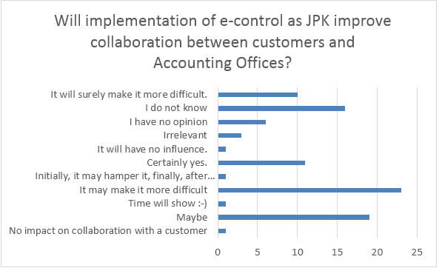
Figure 1 Graphic Presentation of Answers to the First Question
Source: own elaboration

In view of the fact that all data that will be collected in an electronic format in business organizations accounting offices should do their best to convince their clients well in advance to purchase software to create invoices as well as to manage inventory. Such an approach would not only make it easier to download the data but it would also ensure the uniformity of all data in the company. On the long run both sides should see the improvement in the collaboration. Accounting offices should also be aware that accepting documents in the paper form would not only seriously hamper generating of all JPK structures but it would also create a big risk of data inconsistency.
Moreover, if we analyze the statutory requirement to prepare data for The Treasury, it can be stated with no doubt that all processes related to data collecting should be formalized. It means that both external accounting offices and the accounting departments in the companies should take any possible measures to oblige the personnel who is responsible for supplying accounting documents to do it precisely according to the deadlines that are mandatory for submitting tax accounting reports. It will not be done without prior formalization of contacts with well prepared procedures. Due to such an approach the completeness of the data as well as its chronological order can be ensured on the day of reports and declaration preparation and their further transfer to the offices. Thanks to that the cooperation between the offices and their clients should be more efficient.
Again, when we analyze the replies to the second question (Figure 2) related to the possible planed changes in the communication format only 30.42% stated that such formalization of contact will surely be necessary. The remaining nearly 70% of respondents completely ignored that issue. It should be realized that in view of the possibility to generate data files in an electronic version with just a press of the button fiscal authorities may request data from day to day, without any time left to prepare it (as it used to be so far). Without having put the client-office relation into order meeting such demand from the authorities may hardly be possible.

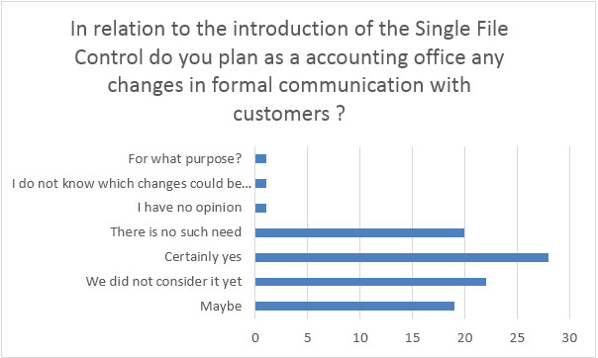
Figure 2 Graphic Presentation of Answers to the Second Question
Source: own elaboration

Disturbing is the fact, that knowledge of SAF-T and e-controlling among the businessmen is so scarce. Over half the accounting offices estimate their clients’ knowledge as negligible and about 30% think that it is difficult to say or the clients do not know anything at all. Since the 1st of July 2018 e-controlling will become mandatory in Poland for all business forms. From that moment each company manager will need a computer, ERP software, access to Internet, qualified e-signature and knowledge, which will allow him to execute statutory requirements in a proper way.

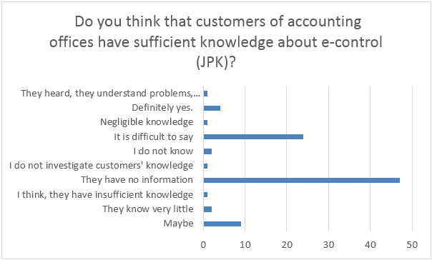
Figure 3 Graphic Presentation of Answers to the Third Question
Source: own elaboration

If that manager will not be able to meet those requirements, outsourcing the service will become necessity to him. It can be expected that the demand for professional accounting services will significantly increase and the accounting offices should already start preparing to that challenge.
4. Summary
By transferring the accounting activities to the accounting office an entrepreneur gives himself more space to get involved deeper in the business itself. However, bad communication is a frequent disadvantage of such collaboration. So, in view of the SAF-T and e-controlling implementations it is improvement of communication that should take the first focus of both parties involved. So far, bad communication resulted in incorrect qualifying of economical operations, delayed receipt of documents and the prolonged waiting time for reports or relevant information. Now the data will have to be collected and registered in the system so that correct structures can be generated in a well-organized and reliable way and transferred to the authorities at any moment at their request. Without a good communication it can be difficult or even impossible.

References
Organization for the Economic Co-operation and Development (May 2005). Guidance for the Standard Audit File – Tax.
Organization for the Economic Co-operation and Development (August 2010). Guidance for the Standard Audit File – Tax version 2.0.
Asquith R., Will EU SAFT reporting be the death of VAT returns?, International Tax Review, available online at: http://www.internationaltaxreview.com/Article/3577749/Will-EU-SAF-T-reporting-be-the-death-of-VAT-returns.html.
Ustawa o podatkuodtowarówiusług z dnia 11 marca 2004, Dz.U.2004 Nr 54poz. 535.
Norwegian SAF-T Financial Data, Norwegian TAX Administration, v. 1.1, 29.04.2016.
SpołeczeństwoInformacyjne w Polsce, WynikiBadań w Polsce w latach 2012-2016, GUS, UrządStatystyczny w Szczecinie, Warszawa 2016, available online at: http://stat.gov.pl/obszary-tematyczne/nauka-i-technika-spoleczenstwo-informacyjne /spoleczenstwo-informacyjne/spoleczenstwo-informacyjne-w-polsce-wyniki-badan-statystycznych-z-lat-2012-2016,1,10.html.

 Magdalena Chomuszko, Ph.D., Sage (Poland) Ltd.; research areas/interests: finance and accounting. E-mail: m.chomuszko@gmail.com.
http://stat.gov.pl/obszary-tematyczne/nauka-i-technika-spoleczenstwo-informacyjne/spoleczenstwo-informacyjne/spoleczenstwo- informacyjne-w-polsce-wyniki-badan-statystycznych-z-lat-2012-2016,1,10.html.

